Module Introduction
In this unit we will present and discuss the data center which is a collection of physical computing resources that are provisioned and shared within the cloud computing paradigm. Innovations in data center efficiency and management are important enablers of the economics behind the cloud computing model. Recall in the previous unit, we discussed some of the benefits of cloud computing as well as the economics behind it. Major advances in data center design play a fundamental role in being able to make this possible. Large-scale data centers can house and run infrastructure more efficiently at scale than what most organizations can manage at small scale with their own infrastructure. Understanding data centers will enable you to be more informed, in terms of performance, cost and potential sources of failure, as you attempt to deploy robust applications and services on the cloud.
This module will serve as a starting step in understanding a few data center fundamentals. We will start with the definition and origins of a data center, followed by a discussion of the current trends in data center technologies: namely the increase in power and resource densities of data centers, as well as the focus on power and efficiency in data centers.

Introduction to Data Centers

Learning Objectives
- Recall the origins of data centers

Data Centers
Data centers include a room or building, IT equipment, and facilities to securely house, power, and cool that equipment. Over the years, data centers have evolved from a location of concentrated IT equipment to modular, agile, and highly virtualized compute centers. With growing use of Web-based services, explosion of mobile devices, and ever-increasing rates of data generation (and consumption), the demand for new data centers continues to grow. One of the main contributors to this growth has been the advent of the cloud computing paradigm, in which cost effectiveness is directly linked to economies of scale and the efficiencies gained with new data center design. All layers of cloud software and services run on top of physical resources, largely servers, storage, and networking equipment, and all of these require power. This equipment also generates heat and so requires cooling. A small data center might fit in one specialized room, while a large installation might be a dedicated, warehouse-sized facility (see Video 2.1).
Video 2.1: Data centers.
Data center design requirements depend on its size and use. Cloud-centric data centers could come in two varieties. An infrastructure as a service (IaaS) cloud provider offers a variety of machine types, and the customers pick and choose to build their own applications. Software as a service (SaaS) and Platform as a service (PaaS) providers typically use large-scale (many thousands) homogenous compute nodes with custom applications that are presented to end users directly. Other types of data centers include enterprise/traditional IT, which houses computers to support functions for day-to-day business operations, and high-performance computing (HPC) data centers, which house large clusters for scientific applications.
In the last 5 years, specific attention has been paid to the efficiency of data centers, dramatically decreasing their operational costs and carbon footprint. This increase in efficiency has led to a fast evolution of data center design, and these trends are likely to continue.
Effective use of cloud resources and development of large-scale, dynamic applications for the cloud require an understanding of the physical resources that make up the cloud. In this unit, we start with trends in data centers, present components that make up a data center, and discuss data center design considerations and requirements.

Why Study Data Centers?
If you think of the cloud as a massive computer, [1] you can still break it down into its constituent parts—processors, memory, and switch. [2] When you are programming for the cloud, you are writing programs that solve a problem or provide a service but with the ability to scale.
A few decades ago, to be a computer user meant to be a programmer. Early programmers knew the instruction set architecture (ISA) well and, because hardware resources were scarce, had to optimize in assembly language. With the advent of high-level languages, such as C/C++, Java, and Python, why do students still have to learn computer organization, caching, and assembly language? When you know what the compiler is doing for you, it makes you a better programmer because you understand what is going on behind the scenes. Similarly, you become better at debugging.
Fast forward to today, when you are developing applications on the cloud, there does not yet exist a compiler that allocates massive virtualized resources automatically to solve your specific problem. It is up to you, the cloud programmer, to do the management and to make your applications cost efficient at scale. Analogous to understanding the components within a single computer, knowing the underlying components of a data center will improve your abilities to program and debug your cloud-based applications.
Most of you will never go on to design and build your own large-scale data center, but understanding what goes into implementing the underlying infrastructure will help you appreciate all of things that cloud providers are doing for you.

Defining Data centers
Formally, a data center can be defined as follows:
Data center
(definition)
Infrastructure dedicated to housing computer and networking equipment, including power, cooling, and networking.
The term data center became popular in 1990s, referring to large rooms dedicated to housing computer and networking equipment, though computer rooms themselves date back much further. Early computers (mainframes) were massive—the size of many refrigerators. They also generated a lot of heat and required clean air filtration to increase reliability. For these reasons, early computers could not be placed into a regular office, so custom rooms were built. A lot of these same ideas go into server rooms today. The only difference is that instead of housing one computer, they hold from dozens to hundreds to even tens of thousands of servers in a single facility.
Modularity is important for data centers because it allows an organization to expand as needed. One of the enablers of a modular data center has been standardized racks onto which IT equipment is mounted. Historically, server racks have evolved from early relay racks found in railroad signaling. It is unclear why the railroad companies chose the original 19-inch, post-to-post width, but the same form factor made its way into early telecommunications and then audiovisual equipment at radio and television stations. Figure 2.1 shows early equipment racks in a radio operators room.
  Did you know?
  The width of early railroad relays dictated the width of a modern 19-in. rack. But the standard gauge of modern railroad tracks (4 ft, 8½ in.) dates back to ancient Greek stone pathways, which the Romans adopted and brought to Europe during the age of the Roman Empire (Wikipedia, 2014).
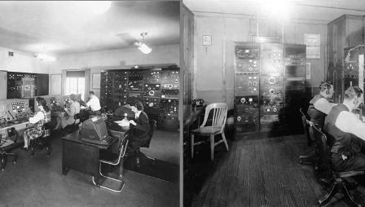Figure 2.1: 1940s radio operators room showing early equipment racks (Inland Marine Radio History Archive, 2012).
A 1933 U.S. patent, F.C. Lavarack, 1,919,166, is an example of a standardized equipment rack for relays. In Figure 2.2, you can see some of the original drawings in the patent.
Some of the advantages of Lavarack's design over common predecessors include:
- Fire safety: Rack posts and other fittings were cast out of iron (and later steel), this became superior to earlier wooden enclosures that could possibly ignite and damage all equipment inside.
- Field assembly: Racks could be assembled using common hand tools and low-skill workers.
- Regularly spaced holes: Support a wide variety of equipment.
- Vertical mounting surface: Easier installation, maintenance, and wiring.
Many of today's standard, 19-inch equipment racks have evolved from Lavarack's design.
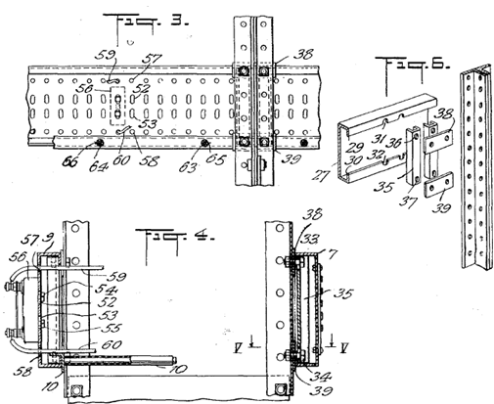Figure 2.2: Relay rack patent drawings (figure from Relay Rack patent).

Size, Density and Efficiency Growth

Learning Objectives
- Recall trends for growth in IT equipment over the past few decades

Growth of Data Centers
Over the past few decades, data centers have grown both in size (in terms of the number of racks and cabinets) and in density. Figure 2.3 is a view of a data center that is owned by Google.
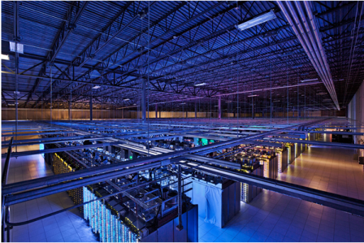Figure 2.3: A view of one of Google's data centers (Source).
Greater density has become possible because of advances in CPUs, integrated circuits (ICs), and printed circuit board (PCB) design. This leads to faster and more powerful computers within the same area.
The minimum size of an element on an integrated circuit (called the feature size) has become smaller by orders of magnitude over the last four decades. Individual transistors have reduced in size from about 10 microns in 1971 to about 0.022 microns in 2014. As individual transistors get smaller, more can fit on the same silicon, so each transistor consumes less power.
Within the same thermal constraints, CPUs have gone from single core to 16core, with transistor counts going from millions to billions. Additionally, accelerators/coprocessors have emerged that provide hundreds of additional floating point units (FPUs) each, with increasing floating point operations per second (FLOPs), per Watt. Also, recent storage arrays have gone from supporting three or four mechanical hard drives per rack unit to 15 to 21 drives per rack unit.
Hence, although the power efficiency of individual components has improved over the years, computers themselves have become more dense, packing in more processing cores, memory, and storage per square foot. This density caused the overall power consumption per rack and per square foot to rise dramatically over the last few years (Figure 2.4). This trend means that both power and cooling requirements also increase per data center.
A large data center now consumes several megawatts of power, which is roughly the same power requirements of a small town.
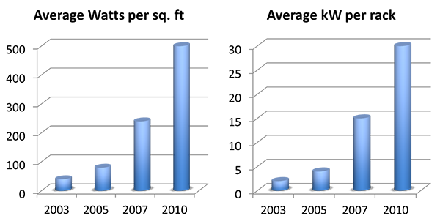Figure 2.4: Trends in power density.
did I get this

Growing in Size and Density
MY RESPONSE...

IT Equipment: Growing in Size and Density: Feedback, Comments, and Bugs

Data Center Efficiency
Information and communications technology (ICT) now accounts for approximately 2% of the global carbon footprint. [1] Within that amount, data centers currently account for approximately 15% (or 0.3% of total global emissions). With the proliferation of ICT worldwide, as more people gain access, the energy footprint of ICT is set to grow considerably for the foreseeable future.
Over the past decade or so, there has been an increased focus on "green" IT, or power-efficient computing. Later in this module, we discuss various methods available in the industry to reduce power consumption and carbon footprint.
Efforts in improving power efficiency in IT exist across many parts of the data center:
- Servers: Entire servers attempt to reduce power consumption by going into idle states, in which they temporarily power down or reduce the power consumption of components when the system is underutilized. For example, a typical server that typically consumes 650W when busy can scale down to about 200W when idle. In addition, virtualization enables better management of IT resources and allows organizations to consolidate individual servers onto fewer physical servers.
Did You Know?
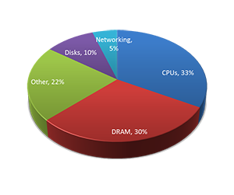
A study by Google quantified the power consumption of each hardware subsystem in their servers.
- Server components: Within individual servers, CPUs and other integrated circuits have gained in performance while maintaining or reducing power consumption. Efforts have also been made to reduce idle power consumption (time periods of low CPU utilization). In addition, dynamic clocking techniques for multicore CPUs enable these CPUs to lower the clock rate of individual cores based on usage and can significantly reduce idle power consumption.
- Power: Systems that distribute and manage electrical power, as well as those providing backup supplies, have recently become targets in the drive for efficiency. Where individual data center racks were previously fed from 110 to 220 volts alternating current (VAC), high voltage (277 to 480VAC) is now becoming more popular because that configuration requires fewer step-down transformers.
The efficiency of a power supply is the ratio of its output power divided by its input power. For instance, a fully loaded, 800W power supply at 80% efficiency would consume 1000W of power, with the remaining 200W lost as heat. These power supplies have gained efficiency recently, with some of them reaching 95%. An alternate design feeds DC to servers directly, instead of converting AC to DC on each rack. Delivering high-voltage, direct current (HVDC) to each server allows using more efficient, DC/DC supplies within the rack.
Large, centralized, uninterruptable power supply (UPS) systems also incur AC/DC conversion losses. To minimize these losses, Google has adopted a decentralized UPS plan, and for several years, its custom-built servers have each had dedicated battery backup. Some manufacturers now offer this server-based UPS configuration for data centers.
- Cooling: Significant advances have also been made in the area of cooling. Eventually, all of the electricity used to power the IT equipment turns into heat (and some noise). This heat has to be dissipated away from the equipment. Traditional server room cooling uses the raised floor plenum with computer room air conditioners (CRACs), but this has limited cooling density. Newer approaches, which improve efficiency and capacity, include hot-aisle containment, in-row cooling, liquid cooling to the rack, and even completely submerging the equipment in mineral oil. Evaporative cooling techniques, as part of the facility, are more energy efficient than chillers and compressors. In colder climates, many server rooms are designed to mix colder outside air as well as reclaim the heat generated by servers for use elsewhere in the building.
The leading driver of increasing power efficiency in the data center is to decrease operating cost. Any power that is drawn from the electric company is billed, but only what is getting to the IT equipment is considered useful, while the rest of the losses eventually become heat. Similarly, the more efficient your cooling system is, the lower your monthly costs.
Techniques to calculate and improve power efficiency in data centers are covered in a later module in this Unit.
Did you know?
Each time you convert from AC to DC, or vice-versa, energy is lost. Similarly, conversions between voltage levels are never 100% efficient.
did I get this

New Focus on Power Efficiency

Challenges and Requirements for Cloud Data Center Design
With the advent of cloud computing, it becomes critical for data center designers to address the cloud's current and evolving needs. In this paradigm, data centers physically host all the cloud services that are delivered to users. In turn, the cloud services are abstracted from the underlying physical resources on varying scales (over a private IP network [i.e., a private cloud] or over the Internet [i.e., a public cloud]), on demand, and for potentially millions of subscribers. Data center design requirements vary according to use, size, and desired functionalities. The cloud model redefines the way data center assets are designed and consumed. Cloud-based services and scale impose new requirements on data centers whereby traffic flows vary, I/O bandwidth and performance demands are significantly increased, and new security concerns are induced. We describe some of the challenges that cloud computing puts on data centers and identify associated requirements for designing cloud-centric data centers.

Scalability
With cloud computing, there is an ever-growing need for expansion and high capacity. For that sake, cloud data centers are typically designed around virtual machines (or instances), which are the units of computing in the cloud paradigm. In contrast to enterprise data centers, cloud data centers offer services to potentially millions of users. To address increasing user demands for services on the cloud, virtualization techniques are usually adopted. With virtualization, data center operators can automatically provision and deprovision virtual machines (VMs) as required, without adding or reconfiguring physical devices. Today. it is not uncommon to provision 20 or more VMs per rack-mount or blade server. Clearly, this load can greatly stress server's resources (e.g., CPU, RAM, and network cards). In addition, this can dramatically increase the number of logical servers that operate over the physical data center network. For instance, with a rack of 64 servers and 20 VMs per a server, a cloud provider would require as many as 1200 IP subnets and VLANs (in networking, a LAN can be segmented into different broadcast domains, each referred to as a VLAN). Furthermore, with only 10 racks, 12,000 IP subnets and VLANs will be needed. This demand creates a major problem because it exceeds the limit (i.e., 4094) of usable VLANs specified by IEEE 802.1Q standard, let alone straining physical switches/routers. Cloud data center providers need to find solutions for such problems.
On the other hand, even with maximal use of virtualization techniques, at a point in time it will be necessary to add physical capacity to support growth. As such, cloud data centers need to be based on modular designs in order to support the easy addition of physical capacity without disrupting applications and services. Designers should specify chassis capacity to support long-term growth so that data center operators can include additional components to the chassis as necessary.

Network Topologies
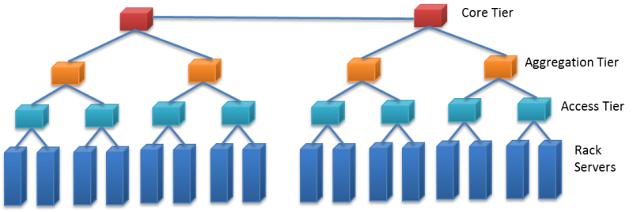Figure 2.5: Traditional hierarchical, tree-style data center network topology.
Most of today's data center networks are based on hierarchical, tree-style designs consisting of three main tiers: an access tier, an aggregation tier, and a core tier. Figure 2.5 shows a sample of a traditional tree-style network topology. First, the access tier is made up of cost-effective Ethernet switches connecting rack servers and IP-based storage devices (typically 10/100Mbps or 1GbE connections). Second, multiple access switches are connected via Ethernet (typically 1/10GbE connections) to a single aggregation switch. Third, a set of aggregation switches are connected to a layer of core switches. Because layer 2 VLANs do not involve IP routing, they are typically implemented across access and aggregation tiers. Conversely, layer 3 routing is implemented at core switches that forward traffic between aggregation switches, to an intranet, and to the Internet. A salient point is that the bandwidth between two servers is dependent on their relative locations in the network topology. For instance, nodes that are on the same rack have higher bandwidth between them as opposed to nodes that are off rack.
Indeed, the network is a key component in cloud data centers. Hierarchical topologies as depicted in Figure 2.5 do not truly suit clouds because they enforce inter-server traffic to traverse multiple switch layers, each adding to latency. Latency in this context refers to the delays incurred by the number of switches traversed, required processing and buffering. Minimal delays in clouds can result in poor user performance perception and loss of productivity. Hence, flatter network topologies with fewer layers to accommodate delay- and volume-intensive traffic are typically required for cloud data centers.

Greater Utilization and Resiliency
Usually, contemporary tree-style data center networks rely on some variant of the Spanning Tree Protocol (STP) for resiliency. STP is a data link management protocol that ensures a loop-free topology when switches/bridges are interconnected via multiple paths. STP allows only one active path across two switches, with the rest being set inactive (assuming many paths are available). On an active path failure, STP automatically selects another available inactive path instead of the failed one. This selection might take STP several seconds, which could turn unsuitable for delay-sensitive cloud applications (e.g., Web conferencing). Furthermore, setting idle backup paths is not the best choice for cloud data centers, especially with the exponential increase in user demands. Cloud data centers require more streamlined and resilient network designs that make full use of network resources and recover from failures in milliseconds to meet demands speedily and utilize resources efficiently.

Secure Multitenant Environment
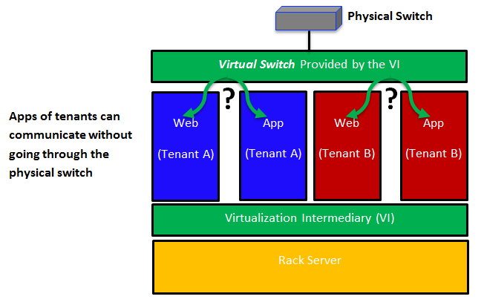Figure 2.6: Workload-to-workload communications in a virtualized environment.
In modern data centers, workloads (e.g., databases, user applications, Web hosting) are typically deployed on distinct physical servers, with workload-to-workload communications occurring over physical connections. Accordingly, securing users can be achieved by conventional network-based intrusion detection/prevention systems. On the other hand, in cloud data centers, multiple VMs can be provisioned on a single rack server, with each belonging to a different user. Thus, workload-to-workload communications can occur within the same server over virtual connections in a manner completely transparent to existing security systems (see Fig. 2.6). Therefore, cloud data centers need to isolate users, protect virtual resources, and secure intra-server communications.

Virtual Machine Mobility
Cloud data centers can host user VMs at servers in one rack, across racks but in the same data center, or at servers across data centers. A cloud can encompass multiple data centers (e.g., Amazon allows users to provision virtualized instances across many data centers). For executing routine maintenance, balancing loads, and tolerating faults, clouds need to periodically and seamlessly migrate VMs between physical servers without impacting user services and applications. This migration does not only require expanding the layer three domain (the domain in which IP routing is required [e.g., WAN]) to move VMs across data centers, but it also requires extending the layer two domain (the domain in which no routing occurs and only broadcasting is employed [e.g., LAN]) in order to span multiple data centers.

Fast and Highly Available Storage Transport
Storage in a cloud data center must support VM mobility and be continually available. VMs that are migrated need to maintain communication with their storage systems. One way to get around this is to move VMs with pertaining storage/data. Clearly, this would require highly available, low-latency, and bandwidth-intensive cloud data center connectivity. Multiple storage models (e.g., Storage over IP [SoIP], Fiber Channel over Ethernet (FCoE), traditional Fiber Channel) are in use today and would further require high-performance and highly available cloud networks. We discuss cloud storage, its challenges, and protocols in the unit on cloud storage.
In summary, data centers tailored for clouds would require the following:
- Modular designs to support exponential growth and the easy addition of physical capacity without any service disruption.
- Flatter network topologies with fewer layers and less equipment and cabling to accommodate delay- and volume-intensive traffic.
- More efficient and resilient network designs that make full use of network resources and recover from failures in milliseconds.
- Capability to fully isolate cloud users, protect virtual resources, and secure intra-server communications.
- VM mobility to execute routine maintenance, achieve load balancing, and tolerate faults seamlessly and speedily.
- Twenty-four seven, 365 days a year service availability and ability to keep migratory VMs connected to their storage systems.

Addressing Requirements for Cloud Data Centers
Data center designers can address the previously discussed requirements at the infrastructure layer, the virtualization layer, or both. For instance, the scalability requirement needs to be addressed at both layers, whereas secure multitenancy can be mainly addressed at the virtualization layer. We study virtualization in detail in the unit "Resource Sharing and Virtualization." In this unit, we are concerned with the infrastructure layer. Accordingly, we present only some of the IT devices (e.g., switches, routers), platforms, and protocols that can contribute to satisfying the requirements for cloud data centers. Because this is a cloud computing course, we do not discuss how the devices, protocols, and platforms work but focus on the benefits they bring to cloud data centers.
To start, data center planners can consider Multiprotocol Label Switching (MPLS) to address cloud infrastructure requirements. MPLS is a highly scalable mechanism that directs data from one server to another based on short path labels rather than long network addresses. Specifically, MPLS labels data packets and enables packet forwarding without examining the contents of packets, which makes packet forwarding quite fast because it avoids routing table lookups and solely depends on packet labels. Consequently, MPLS allows creating end-to-end circuits across any type of transport medium, a key requirement for server-to-server communication across cloud data centers.
As previously discussed, in cloud computing, different types of traffic are imposed, and variant bandwidth requirements are induced. Without considering MPLS, separate layer two networks might be necessary to build, which clearly is not a scalable solution in cloud data centers and can greatly increase both capital and operational expenses. By contrast, with MPLS, networks can be shared via creating virtual network connections called label switched paths (LSPs). Furthermore, quality of traffic flows over the LSPs can be flexibly controlled. Such traffic control facilitates end-to-end quality of service (QoS) and provides fast network convergence (approximately 50ms) in case of link failures, a remarkable improvement over STP. As a result, the transparency of network failures can be highly improved, and service disruptions can be reduced, which are other key requirements for greater resiliency on cloud data centers.
MPLS also allows enabling virtual private LAN service (VPLS) to extend layer two connectivity across multiple data centers. VPLS is a virtual private network (VPN) technology. VPN is typically utilized to implement secure connections between LANs located at different sites (i.e., data centers) using public Internet links. VPLS allows different LANs at different data centers to communicate as if they are one LAN, a key requirement for streamlining VM mobility. VM mobility can also benefit from the aforementioned traffic controlling capability offered by MPLS.

Summary
Several vendors are now marketing cloud-centric networking and compute products to address several of the design goals stated earlier. Most of these products are variations on what you would find in a traditional data center, with a shifted focus on density and concurrent users. A data center designer who wants to support private or public clouds has a growing catalog of products from which to choose.
Data center design has evolved rapidly over the last 5 years; this trend is not slowing down. The data centers 5 or 10 years from now will most likely look very different than the data centers of today. Data center designers are addressing new requirements while improving efficiency and the TCO to deliver a cloud service. With the advent of pre-engineered modular data centers, soon the facilities will become interchangeable components, much like the IT equipment itself. To meet the growing consumer demand for new cloud-based services, as well as address IT infrastructure needs of existing enterprises, we will see more and more data centers, with each generation more efficient than its predecessor.

/Summary

Data Center Trends Summary
- A data center is a term that refers to infrastructure dedicated to housing computer and networking equipment, including power, cooling, and networking.
- Data centers have evolved from simple rooms housing mainframe computers to large warehouses that store thousands of individual servers.
- As an organization's IT needs continually increase, modularity in data center components allows an organization to expand its infrastructure as needed.
- Servers are getting more and more dense, packing more CPU, RAM, and storage into each square foot. This led to greater power consumption per rack. It is common for existing data centers to run out of power or cooling before running out of floor space.
- Industry aims to increase its focus on "green" IT, or power-efficient computing, both inside and outside the server. This efficiency reduces power consumption and carbon footprint, decreasing operating expenses and increasing profit.
- Data centers are becoming more efficient in the last few years through advances in virtualization, power-aware server hardware, efficient power distribution, and advanced cooling techniques, among others.

Data center component:

Module Introduction
In this module, we will discuss the various components (equipment and facilities) of a data center. We will start with a discussion on IT equipment, and will clarify many server-specific terminologies that you may have encountered. Most hardware vendors provide servers that are configurable in terms of compute, storage and networking. We will present in detail these server components. While these topics can be information-dense, the choices made while configuring servers have a major impact on the cost and performance of applications that are run on them. Therefore, an exposure to the spectrum of servers and related technologies will be useful, especially if you pursue a career that utilizes or manages cloud infrastructure.
Also, in this module, we will discuss data center facilities. Specifically, we will present some of the recent advances in power and cooling techniques which provide additional efficiency to today’s data centers. We also cover a few additional facilities-specific aspects regarding fire and safety in data centers.

In this section, we define IT equipment as anything that is mounted in a rack (called rack-mounted equipment). This equipment typically includes servers, dedicated storage arrays, network switches and routers, power distribution, and remote management devices. We are specifically referring to a four-post rack inside a cabinet enclosure. Additional types of racks are described on the next page of this module ("Facilities").

Servers
A rack-mounted server is similar to a tower PC, except turned horizontally and made to fit into a thinner, deeper chassis (Figure 2.7). The heights are measured in multiples of rack units, where 1U = 1.75 inches (4.45 cm). A 1U server can be CPU and RAM dense but leaves little room for I/O expansion cards (usually two). A server that is 2U or 3U can have six to eight I/O card slots. Smaller chassis must also have smaller fans and therefore make considerable noise compared to your average desktop computer (this is acceptable because most server rooms are not occupied by humans). Systems that are 4U, 5U, or larger chassis usually have a specialized function: one example is an 80-core Intel server, which has CPU sockets and RAM on vertically mounted daughter cards; another is a quad-GPU accelerator server; a third is a server chassis with a 24, 36, or 48 internal hard drives.
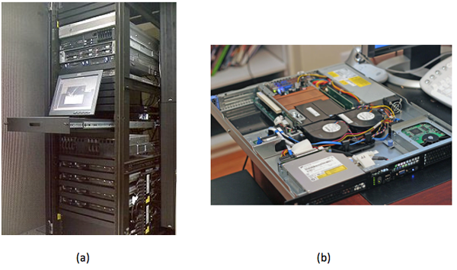Figure 2.7: (a) Servers and other equipment mounted in a standard 19-inch rack (Source). (b) A 1U server with its top cover removed to reveal internal components (Source).
Rack-mounted servers have their own fans, power supply units (PSUs), network, and I/O, but blade servers share all of these across many nodes within the same blade enclosure (called blade chassis). There is no common blade standard, so each vendor's blades work only with its enclosures. Blades are thin, vertical metal enclosures and slide into the front of a blade chassis and attach to a common backplane. Each blade has its own motherboard, CPU, RAM, and disk. The shared PSUs are typically more efficient than dedicated rack-mounted versions because they can power up or down incrementally, adjusting PSU capacity to load demand. For example, instead of 10 servers with 2 * 750W redundant PSU, a blade enclosure can power the equivalent of 10 servers with 4 * 2500W PSU, with one being redundant. Blades are denser than their horizontally mounted counterparts, allow for easier maintenance, and require fewer cables. The disadvantage is higher upfront cost if you only need a few servers, plus you are locked-in to a specific vendor.
Last, there are a few servers that look similar to a standard rack-mounted server, except they have two motherboards horizontally per 1U, each mounted on its own tray. They also share a PSU but, unlike blades, have their own fans and I/O. There are variations on this theme, such as four nodes per 2U or two nodes with multiple GPUs.
Did you know?
A 1U rack-mounted server is sometimes referred to as a "pizza box."
The following video (Video 2.2) describes various server form factors:
Video 2.2: Server Form Factors.
An important feature found in most rack-mounted servers is hot-swap capability. Components such as PSU, fans, and hard drives can be removed and replaced while the server stays running. This feature increases uptime/reliability on small- and medium-scale deployments. Large-scale application deployments require more sophisticated resiliency to be built into software layers, which is discussed in the next unit. These large-scale systems do not use hot-swap or redundant components for individual servers but instead consider the entire server to be failed (and replaced) as a unit.
The electrical components (e.g., capacitors, voltage regulators) of a server are typically more expensive and longer lasting than those parts used on desktop systems because the servers are designed to run 24/7 for many years on end. A workstation is similar to a server class computer, with similar CPU, high RAM capacity, and added reliability. The difference is that a workstation sits at the user's desk, so it requires quieter fans. To add to the confusion, there are also rack-mount workstations, which are just like a server, but have remote viewing capability, so the end user sits at a thin client.
Newer servers are now being designed to run reliably at higher ambient room temperatures (up to 95°F, or 35°C), which decreases cooling requirements and therefore lowers operational expense.

On the Motherboard/Mainboard
CPU and memory: A typical server motherboard has more CPU sockets than a desktop system, and each of those sockets can control more DIMMs (dual inline memory modules). Another primary difference of server-class CPUs versus desktop class (Intel Xeon versus i3/i5/i7; AMD Opteron versus FX/A/Phenom) is more onboard cache, support for registered DIMMs, and support for error-correcting code (ECC) RAM.
Server-class CPUs also have dedicated circuitry that allows them to communicate with each other through dedicated channels in the motherboard. For Intel, this is known as QuickPath Interconnect (QPI), and for AMD, it is known as HyperTransport (HT). These follow a nonuniform memory access (NUMA) model, in which processes running on other CPUs (sockets) can access large amounts of RAM by going through QPI or HT to the RAM attached to another CPU. Combining high-density, registered DIMMs (16GB or 32GB), more DIMM slots per server (9 or 16), and multiple sockets with onboard interconnect, a single server can have 512GB or even 1TB of RAM available to a single process (although you get higher performance when you have multiple processes with multiple threads each, but that is a topic for another course).
Onboard management: Although many desktop motherboards now have onboard gigabit Ethernet (GigE) networking, this trend started with servers, and on modern servers, you will find two to four GigE ports. Other onboard devices that a server includes are a serial port for console redirection and an embedded management controller, which allows remote management even if the system is powered off (but still plugged in) or if the OS is not responding (i.e., kernel panic). Many server motherboards have onboard hard drive controllers, but these are also common in the form of an expansion card, which is discussed below.

Expansion cards
PCI Express: Often, a server requires additional I/O devices, depending on the applications intended to run on it. PCs and mainframes have always had some notion of expandability, and expansion buses have evolved from ISA to PCI to PCI-X to what is the current standard—PCI Express (PCIe). The biggest difference between PCI and PCIe is that PCIe is based on point-to-point, high-speed serial links, rather than an actual bus, which has multiple devices attached. Each of these high-speed links constitutes a lane, and multiple lanes work in parallel. So a PCIe device that is x8 has eight of these high speed lanes. Each generation of PCIe, from 1.0 to 3.0, effectively doubles the bandwidth of the previous generation.
Table 2.1: PCIe generations throughput per x1, x4, x8, and x16 lane slots.
PCIe Generation | x1 (MB/s) | x4 (GB/s) | x8 (GB/s) | x16 (GB/s)
1.0 | 250 | 1 | 2 | 4
2.0 | 500 | 2 | 4 | 8
3.0 | 985 | 3.94 | 7.88 | 15.75

RAID: RAID (redundant array of inexpensive disks) adapters allow multiple hard drives to act as a single logical unit, with increased performance and redundancy or a mixture of both.
Table 2.2: Different RAID levels with major advantages and disadvantages.
RAID Level | Name | Advantages | Disadvantages
0 | Called block-level striping. | Improved performance. | No fault tolerance, and a single drive failure destroys the entire array.
1 | Called mirroring because data is replicated entirely. | Can withstand drive failure. It has faster reads (sometimes), and this level maintains performance on failure. | One-half the capacity versus two independent drives. This level has slower writes.
10 | Called RAID 1+0 or ten(mirroring+striping). It combines the speed of RAID 0 and redundancy of RAID 1. | Provides fault tolerance. It has improved performance. This level maintains performance on failure. | One-half the capacity versus two independent RAID 0 arrays.
5 | Block-level striping with distributed parity. | This level can withstands single drive failure, and it has more capacity versus RAID 1, 10, and 6. | Slower writes than RAID 0, 1, and 10, degraded performance on failure, and slow rebuild process.
6 | Block-level striping with double-distributed parity. | Withstands two drive failures and has more capacity versus RAID 1 and 10 (with more than four drives). | Slower writes than RAID 5, degraded performance on failure, and slow rebuild process.

RAID controllers come with different number of ports (connected drives), support different interfaces (SATA, SAS), vary in amount of built-in cache (e.g., 512MB, 1GB), and have varying performance levels (MB/s throughput, I/O per second). Each of those factors can change the price of the adapter (from a few hundred to over $1000).
A host bus adapter (HBA) is similar to a RAID controller, except that it connects to external storage (discussed in the next section) and does not typically include any RAID features on the card itself. The card will encapsulate all communication, so the remote disk device will look like a local disk to the OS and is bootable.
Networking support: Ethernet network adapters can include single or multiport cards, with speeds ranging from 100Mbps (obsolete) to 1Gbps (common, inexpensive), then came 10Gbps (becoming more prevalent but still expensive), and now 40Gbps (available but not common yet).
A host channel adapter (HCA) refers to a high-speed, low-latency interconnect adapter, such as Infiniband. These are typically used on high-performance computing (HPC) clusters.
Solid-state storage cards are now available, such as those from Fusion-IO. They provide much faster performance than RAID controllers, especially on random I/O. They have a very high cost per gigabyte compared to hard disk drives (HDDs) or even solid-state drives (SSDs) (see the following "Storage" section).
Accelerators: Video cards, started in desktop computers, use GPUs for fast 3D rendering. These GPUs can also be used for scientific computation, so they made their way into HPC server markets, and now nVidia Tesla series accelerators can be found in more than 50 of the top 500 supercomputers list. Recently, Intel released an accelerator product, the Xeon Phi, which is based on Many Integrated Cores (MIC) architecture and is similar in performance to Tesla product (>1 teraFLOPs). These cost approximately $3000 but can increase performance 2.5x to 10x (often) to 100x (atypical) for math-intensive applications. Note, however, that these will not fit into your average server case due to the large size of the card and additional PSU requirements.
did I get this

Data Center Components: Servers
learn by doing

Server Configuration
Company X wants to expand its private cloud for hosting a new Web application composed of many Linux virtual machines running in a VMware ESXi 5 environment. They do not want to use more than one rack of equipment, so they like the density that blade servers provide. They have benchmarked their application and found that a blade server with 2 x Intel Xeon E5-2660 performs 40% faster (i.e., 1.4x) than a blade server that has 2 x AMD Opteron 6276 CPUs. They use a fast QDR Infiniband network and fast enterprise-class SSD drives in each blade server, so the only bottleneck for the applications is the CPU.
Each blade enclosure/chassis is 7U tall and can house 20 blade servers (each blade is a two-socket blade). The enclosure itself costs $12,200 and includes power supplies, fans, gigabit Ethernet, and Infiniband network switch modules. These particular blades must be bought in pairs because of the way they stack in the enclosure.
The price of the Opteron 6276 processor is $850 (per socket). The price of the Xeon E5-2660 processor is $1370 (per socket).
Configured to Company X's requirements, the AMD blade servers cost $4875 each, and the Intel blade servers cost $6700 each. The company intends to configure the enclosures with the exact number of blade servers as determined in the scalability testing mentioned above.

Storage
When most people hear the word storage, it is likely that they will envision an HDD (Figure 2.8(a)). Inside an HDD, the rotating platters and moving read/write head have been similar for decades. What has evolved are higher areal density, new recording techniques, faster interfaces, and overall lower power. The two most common form factors of HDDs are 3.5 inches and 2.5 inches. Rotational speeds can vary, but common RPM values are 5400, 5900, 7200, 10,000, and 15,000. The higher the RPM, the lower the latency between random seeks.
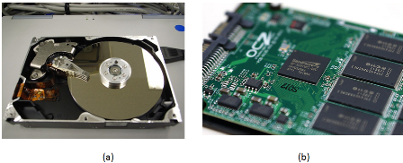Figure 2.8: (a) Internal view of a traditional hard disk showing the rotating platters and read/write head (Source). (b) SSD with the circuitry exposed (Source).
Did you know?
The maximum physical capacity of a hard drive is governed by what is called the superparamagnetic limit.
SSDs (Figure 2.8(b)) are becoming more affordable but still have a much higher cost per gigabyte than their mechanical counterparts. SSDs are completely electronic; there are no moving parts, which gives lower seek times, higher performance, and higher reliability. SSDs do have a limited number of writes, but one would have to continuously write to the drive 24 hours a day for several years to reach that limit. The terms SLC,MLC, and TLC refer to how many voltage levels there are in each cell: S is for single (1), M is for multi (2), and T is for triple (3). The fewer the levels, the more reliable it is (SLC > MLC > TLC). The more levels, the higher the density (TLC > MLC > SLC). SLC is generally reserved for high-throughput transactional servers. MLC is the most common replacement for desktop and laptop drives, plus servers that need higher I/O performance than a fast (10k or 15k rpm) HDD can provide. TLC is emerging as a lower cost alternative to MLC, but somewhat compromises performance and reliability to achieve a lower price.
The hard drives that are found in data centers are nearly identical to those found in desktop PCs. The primary difference between an enterprise and a regular SATA drive is added antivibration protection, which claims to increase the lifespan of drives that are rack mounted with many other drives in the same chassis. They also come with longer warranties—5 years instead of 3.
SATA (serial ATA) and SAS (serial attached SCSI) are the two predominant interfaces for all modern HDDs and most SSDs. For servers, SAS provides the ability for a single drive to "talk" to two drive controllers (in case one controller fails). SAS also requires lower CPU usage and provides the ability to daisy chain a large number of drives via an SAS expander. Most RAID controllers that support SAS also support SATA, but the inverse is not true.
Direct attached storage (DAS) refers to a rack mount chassis that holds additional drives, along with PSUs and fans, but minimal control logic. All of the work is done by the controller (on the server) that these units attach to. A typical connection is made through external SAS cable (high-speed serial, multilane, copper).
A storage area network (SAN) is a collection of hard drives in a chassis that can be connected to many servers. A system admisinstrator will carve the array into LUNs (storage logical unit numbers), where each LUN can be used for a different purpose. Many servers connect to the same SAN simultaneously, but only one server accesses a given LUN at a time (unless a coordinated sharing software is installed, such as VMware). Servers connect to the SAN through a network, typically Fibre-Channel or iSCSI over Ethernet (1Gb or 10Gb). Each LUN gets a unique World Wide Name (WWN), which can be used for zoning and masking, providing security so that servers can only read the LUNs that belong to them. Access can also be restricted by IP and subnet.
Most commercial SAN products span multiple rack units or even multiple racks, and have multiple redundant controllers and network paths to increase uptime. SANs have embedded RAID controllers, so disk failures are transparent to the attached servers. SAN products vary greatly and, depending on features, performance, and capacity, can range from $5000 to several million US dollars.
Network attached storage (NAS) is a device or server that shares a file system to multiple users over the network. Any Linux server can become a NAS, and many consumer dedicated NAS devices run Linux underneath. The two most common protocols used by a NAS are called CIFS (Common Internet File System, also called SMB [Server Message Block]) and NFS (Network File System). CIFS comes from Microsoft Windows' heritage and is a per-user connection in which NFS is primarily used on UNIX/Linux and is a per-host connection.
Last, there are also many Distributed Parallel File Systems, which are typically used in compute clusters and implement a many-to-many scheme. These provide a much higher combined throughput than any single SAN or NAS and can scale in both performance and capacity.
The choice on which type of storage to use is largely dependent on the application, and most organizations will use a combination of the above. For example, a large storage array uses a parallel distributed file system on its internal back-end network but presents both SAN-style LUNs and provides NAS capability for other clients. A Windows file server will look like a NAS to a client mapping a network drive, but it is likely that the storage device in which files actually reside are in a SAN, which is outside of the Windows server itself. When you learn about resource sharing in the next unit, some of those features (live migration, fault tolerance) require a SAN storage device.
did I get this

Data Center Components: Storage

Networking
In addition to servers, a data center houses all of the network equipment that is used to connect those servers to each other and to the outside world.
One popular design is the multitier topology (Figure 2.9), in which servers connect directly to switches, and those switches link to aggregation switches, which, in turn, connect to the rest of the organization's network (i.e., core switches) and eventually to the upstream ISP.
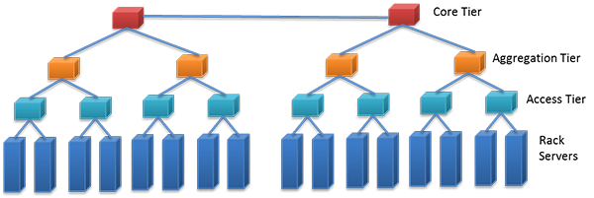Figure 2.9: A stack of network switches mounted in a rack (Source).
A fatter (higher bandwidth) connection typically links the bottom-tier and aggregation switches. For example, with 48x1Gb ports connecting the rack servers and the access tier, the access to the aggregation tier might have 2 * 10Gb uplinks.
Top of rack (TOR) refers to a configuration in which the lowest tier of network switches are found in each rack. This design can decrease cabling cost and complexity because the wires are shorter and can be copper even at 10Gb speeds. This is especially useful if most of the network traffic is to other servers in the same rack. Apache Hadoop, for example, can take advantage of this topology for choosing which nodes to store data (on rack and off rack) and which nodes from which to retrieve data (on rack). One disadvantage includes limited scalability. Ethernet switches are blocking, which means that if all the ports are busy at the same time, the backplane cannot handle all the traffic, so some requests are postponed. Also, the uplinks that are available are typically less than the full possible bandwidth of the Ethernet switch (e.g., you cannot have a 48Gbps uplink on a 48x1Gb switch). In most real-world scenarios, however, those uplinks are never saturated because not every server is using the full capacity simultaneously. Another disadvantage is port utilization. Switches come with a specific number of ports, typically 24 or 48, so if you have a number of servers in between that, you will have some ports in each rack that are never used.
End of row (EOR) refers to a configuration in which you have a row of adjacent racks, or a row of back-to-back racks,sometimes called a bay, and there is one additional rack dedicated for network switches, and all of the hosts in that row (or bay) are wired to that dedicated rack. Wiring is either done above the racks in a wiring tray or below the racks, underneath a raised floor (more on that in the next section). The switches in this dedicated rack can be a larger (10U+) modular chassis, in which each module communicates to other modules through a fast backplane. The advantage is that all servers in the same row (or bay) can communicate with each other at the same speed (and lower latency), so there are fewer bottlenecks. The disadvantage is higher upfront cost and more complex cabling (harder to debug if there is a problem). Gigabit links can still be copper at this distance, but anything 10Gbps or above should be fiber.
Ethernet is by far the most popular type of network in data centers (and elsewhere in organizations). Although its rise in popularity started in the 1980s with 10Mbps, both that and 100Mbps products are obsolete because of the low price and ubiquity of 1Gbps products. The primary driver for Ethernet popularity is the low cost and ease of installation of twisted pair wiring. The most common type of Ethernet wiring is unshielded twisted pair (UTP) (Figure 2.10(a)), which has four pairs of thin (28awg) copper wires and comes in different categories: category 5 (Cat5) is good for 10/100Mbps, Cat5e and Cat6 are good for 1Gbps, and Cat7 can go up to 10Gbps. Each generation has slight design changes over the previous, which allow for greater bandwidth and/or longer runs. Alternatively, shielded twisted pair (STP) has an extra metal shielding on the outside for use in electrically noisy environments (such as a factory or near high power lines). The shielding reduces interference but is generally not needed for most in-rack installations.
Ethernet can also travel over fiber (sometimes fibre) optic cable (Figure 2.10(b)). Fiber is unidirectional, so in a cable, you will see two strands, one send and one receive. The electrical signals are converted to photons, which stay inside the fiber due to the differences in indexes of refraction between the core (thin center) and cladding (thicker outside layer). The cladding is covered by a layer of fireproofing material. Fiber cables are thinner and lighter than copper cables, but care has to be taken in routing to maintain a minimum bend radius, otherwise some photons escape causing loss. Multimode fiber is most commonly used inside data centers because the cables and transceivers are much less expensive than single-mode fiber. Single-mode fiber is generally reserved for long-distance (>100m to 40km) connections. Higher speed Ethernet of 40Gbps is actually 4x10Gbps links that work in unison (similar to PCIe lanes); similarly, 100Gbps is 10x10Gbps (copper, fiber) or 4x25Gbps (fiber only).
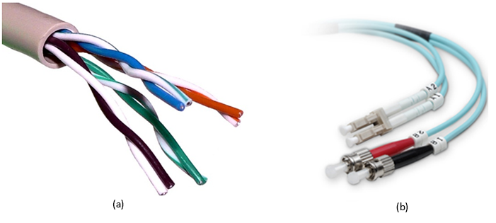Figure 2.10: (a) A cutout of an unshielded twisted pair (UTP) cable, showing four pairs of cables (Source). (b) Fiber-optic network cables with LC (top) and ST (bottom) connectors (Source).
Fibre Channel (FC) is a protocol designed to support SANs and remote block-level storage devices. Even though it typically runs over fiber, it can also run over copper. It can also be encapsulated in Ethernet in the form of Fibre Channel over Ethernet (FCoE) but is not routable like iSCSI. Fibre Channel HCA and switch generations are named by their speed (in Gbps)—#GFC, in which # is 1, 2, 4, 8, 10, or 16. The most common now is 8GFC, which supports 8Gbps links (approximately 800MB/s in each direction).
iSCSI, or internet SCSI (pronounced "scuzzy"), is a protocol which packetizes SCSI (Small Computer Systems Interface, an old hard drive standard) commands to be transported over LANs or WANs. Many SANs support iSCSI, and it is popular because you can use your existing Ethernet network instead of deploying a dedicated FC network.
Infiniband (IB) has been popular in HPC clusters for almost a decade and is also gaining traction in other areas in the data center. The main advantage of Infiniband is much lower end-to-end latency compared to Ethernet (1.7 microseconds versus 12.5 microseconds for 10GigE versus 30 to 100 microseconds for GigE). It also scales better with the number of nodes in a cluster. The other key factor in IB performance is that the switches (Figure 2.11) are fully nonblocking, which means that the backplane supports running every single port at full speed, in both directions. Infiniband speeds are summarized by the chart below:
Table 2.3: Summary of Infiniband speeds.
SDR | DDR | QDR | FDR-10 | FDR | EDR
8Gbit/s | 16Gbit/s | 32Gbit/s | 40Gbit/s | 54.54Gbit/s | 100Gbit/s

Infiniband and 40Gbit Ethernet are also being deployed as a converged network, or virtual fabric, which, along with virtualization of the OS, allows many virtual adapters (Ethernet, FC-HBAs) to run over fewer high-speed links. The connections can be configured dynamically through software and allow for fewer cables and easier maintenance and management.
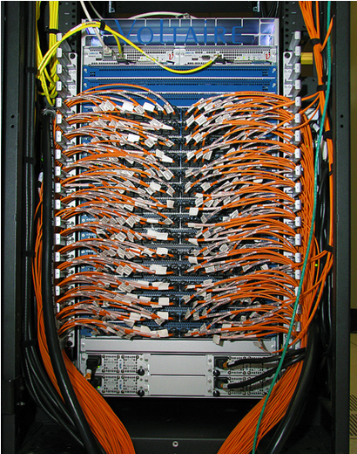Figure 2.11: An infiniband switch (Source).
The choice of network technology and topology to deploy in a data center also depends on your applications but will typically include multiple tiers, with the connection between the tiers being high-speed fiber. Copper UTP cabling is prevalent within the rack and will continue to function well for low-speed management networks.
did I get this

Data Center Components: Networking

Data Center Facilities
A data center's functional units (servers, storage, networking) all rely on a facility's infrastructure, which includes physical space, power, cooling, and safety. In assembling each of the latter component systems, designers prioritize redundancy issues. Redundant power sources, for example, minimize the risk of service outages should the building lose main power. Redundant cooling avoids physical damage to IT equipment during an unplanned outage and enables planned outages for HVAC equipment maintenance.

Server Room
A server room can vary in size from a single rack in a closet to several hundred square feet to a warehouse the size of a football field. Some authors use the phrases server room and data center interchangeably. For the purpose of the course, we define a server room as the actual room that houses all of the racks full of IT equipment, and a data center as the server room plus all of the power and HVAC equipment that may be located outside of that room.
You were already introduced to the concept of a rack and a rack unit (U). Figure 2.12 shows a rack inside an open cabinet. Sometimes racks are also called cabinets. There are several variations of racks, but the most common are 19 inches wide (measured from the center of each hole on the same U). Some IBM equipment racks measure 24 inches post to post, inherited from older mainframes. Usually, network equipment is designed to mount only on two posts of the rack because wiring closets often have only two posts permanently mounted to the floor and/or wall. Servers, however, are designed to mount on four-post racks. The depth of the rear two posts is not standardized, and in most racks you can adjust the depth. Different rack-mount equipment has different depths, and each server or storage array will come with two mounting rails that connect to the front and rear posts on the left and right sides. There are two types of holes in vertical posts, square and round. Some mounting rails hook directly into square holes and have tool-less installation (fast). For round-hole racks, equipment is directly screwed in (these are more popular for telecom and A/V racks). If you need to mount round-hole style equipment or rails into a square-hole rack, you use cage nuts and bolts. | 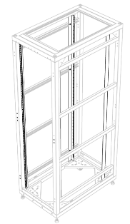Figure 2.12: A 42U, four-post rack/cabinet, with sides and doors removed.
The most common height rack is 42U, and that is simply to fit through a normal doorway. The overall height, width, and depth of racks by different manufacturers are not exactly the same; the only guarantee is the post widths. Some racks have extended depth, which is useful for larger servers and/or routing cables and mounting zero-U (vertical mount outside of the 42U space) equipment. "Wide" racks have extra space to the left and right of the posts, which is useful for end-of-row networking racks because of the added space to run many cables. Racks also have casters that allow them to be rolled into place or moved if needed. However, these wheels are not meant to permanently support the full weight of a filled rack, which is why you have to screw down the four stabilization feet at each corner. Regions that are prone to earthquakes also have safety regulations that require racks to be bolted into concrete through metal plates on the front and rear of the rack.
Many server rooms have a raised floor, although it is not a strict requirement. This provides a plenum for cold air to be distributed throughout the room (tiles in front of racks have vent holes). Raised floors also provide space to run electrical or network cable or chilled water pipes for in-row cooling. Last, they provide more flexibility for future layout/configuration changes. Figure 2.13 shows what a raised floor looks like.
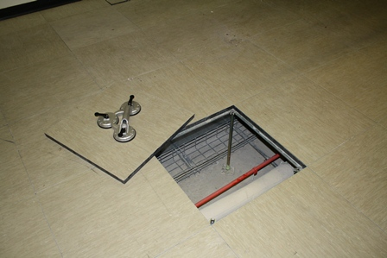Figure 2.13: An example of a raised floor.
The floor consists of an array of metal support pedestals, which are mounted to the subfloor; metal stringers that are placed horizontally between pedestals; and strong floor tiles that rest atop the stringers at each corner at a pedestal. When a tile is removed, the holes are large enough for a human to fit through, and the tiles are strong enough to withstand the weight of a filled rack. Tiles do have a rollover rating, however, and for safety reasons, any tile that has been rolled over (moving a filled rack on top of it) more times than it is rated for should be replaced. Also for safety reasons, on a stringerless floor, no more than two or three consecutive tiles should ever be lifted from the floor simultaneously. If there is a problem with one of the pedestals, weight can shift laterally, cascading to a catastrophic floor failure.
Above the racks are cable trays that run horizontally between racks. There are options to hang these from the ceiling, or some racks have optional trays that mount on top. For electrical safety, these are required to be properly earth grounded, even if they are carrying only network cable. When there are a many wires to run between two racks, hook-and-loop (Velcro) fasteners are most often used to bundle the wires together.
Most data centers implement strict physical security procedures—for good reason. If someone with bad intentions had physical access to a server, they could, for example, gain administrative privileges, steal data, eavesdrop network connections, and install viruses/Trojans. Common practice includes keycard/pin access and/or biometric scanner, full time security guard, cameras, and break-in detectors. In shared data centers with multiple tenants, one technique is to have a perimeter chain-link fence with a padlock around each customer's set of racks. Watch Google's security practices here.
did I get this

Data Center Components: Server Room

Power
The following video (Video 2.3) discusses various power distribution methods in data centers:
Video 2.3: Data center power distribution methods.
Reliability/uptime is often the number-one design consideration for a data center. Unfortunately, the power feeding the data center is not 100% reliable because of events such as bad weather conditions and downed power lines. In some locations, it is possible to get feeds from multiple electrical utility suppliers, but often this is not available. To keep the IT equipment powered on during a power outage, a generator can be installed. Backup generators come in two varieties, powered either by diesel fuel or natural gas. They could power the data center indefinitely as long as fuel is available, but both fuel sources are significantly more expensive than electricity from the grid. Generators are typically mounted outdoors due to fumes, noise, weight, and vibration. An automatic or universal transfer switch is a device that can choose a working power source (utility 1, utility 2, or generator) and connect it to the main power input to the data center.
Generators have a 15- to 60-second start-up time, so this is where an uninterruptable power supply (UPS) can provide power to the IT equipment until the utility power is restored or the generator is running. UPS have many lead-acid batteries (like in a car) strung in series. For example, a 480-volt UPS would have a string of forty (40) 12-volt batteries. A UPS also act as a line conditioner and will switch to a DC battery source if it detects poor AC conditions, such as surges, sags, overvoltage, undervoltage (brown out), and variations in wave shape or frequency.
Between the UPS and the IT equipment, there are power distribution units (PDUs). Think of PDUs as similar to power strips you use at home but designed for higher voltages and amps, with more outlets and built-in circuit breakers. They often include monitoring features, so you can remotely see the power draw per branch (group of outlets connected to a single breaker). Some also include per-outlet power sensing (POPS) as well as remote ON/OFF switching for each outlet. The outlets for PDUs do not look like the electrical outlets in your house; instead, they are IEC 60320 C13 (said "C thirteen") (Figure 2.14(a)) for 10- to 12-amp rating and C19 for 16 to 20 amps (Figure 2.14(b)).  For AC, higher voltage (400V and 480V) is more efficient for distributing power throughout a data center than 240V or 208V but still has to be stepped down before going to the actual server. Most server power supplies are universal and will accept input AC voltages ranging from 110V to 240V. The benefits to running at 208 to 240V versus running at 110 to 125V are slightly higher efficiency (5% to 10%) as well as getting the full rated power output (as labeled on the PSU). Most server room/data center installations will run at 200+ VAC for the efficiency, as well as lower pricing for electrical wiring (smaller gauge copper). In order to boost efficiency, some server PSUs also support 277V directly. Instead of traditional wire, some server rooms employ bus bars that mount over head (above the racks) and have circuit breaker whips that can attach at any horizontal location (these are like track lighting, only larger). | 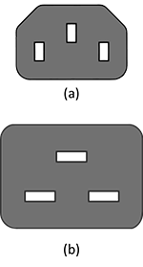Figure 2.14: Diagrams of the (a)C13 power connector and (b)C19 power connector (Source).
Some vendors offer DC distribution, in which the AC-to-DC conversion is done per rack, per row, or per bay, rather than converting AC to DC within every server power supply. These systems have been measured to be more efficient than their AC counterparts, but only 2% to 4% for average loads. [1] Because DC power supplies are not a commodity, these are only suited for large-scale deployments with custom components.
did I get this

Data Center Components: Power

Cooling
Many of the advances in data center efficiency over the last 10 years have come from new designs and methods for cooling.
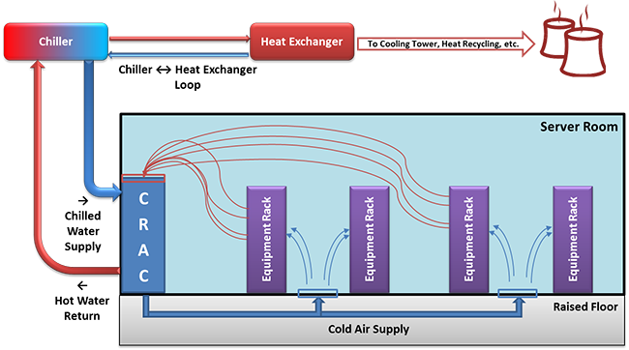Figure 2.15: Typical data center cooling technique. Figure shows the use of a CRAC and raised floor.
Commonly found in traditional server rooms are computer room air conditioners (CRAC or CAC). These continuously take in hot air and output cold air into the space under a raised floor or into ducts. The difference between a CRAC and a regular air conditioner is that CRACs also provide humidity control. Keeping a relative humidity around 40% is recommended. If the air is too wet, you get condensation (bad for electronics and anything metal), or if it is too dry, you get a higher risk of ESD, or electrostatic discharge (also harmful to electronics). The units' fans have to be sized large enough to create positive pressure and airflow for the volume of the room and have sufficient cooling capacity to maintain the desired "cold-aisle" air temperature (more on hot and cold aisles below and in the next module). The CRACs remove heat through the use of a condenser (similar to what is in your refrigerator at home) or through a heat exchanger that uses chilled water supplied by chillers elsewhere on site.
Measurement of energy for electronics is usually in kW, but most HVAC equipment is measured in tons or BTU/h, so here are some conversions:
- 1 kW = 3412 Btu/h
- 1 ton = 12,000 Btu/h
Did you know?
A BTU, or British thermal unit, is the amount of energy needed to heat 1 pound of water to 1°F, and a ton is the heat absorbed by melting 1 ton of ice in 24 hours.
Using vapor compression, chillers remove heat from water in a closed-loop, high-pressure system, usually outputting water that is approximately 42°F (5.5°C). Chillers themselves need to dissipate the heat they remove from the water, which can be through air cooling (fans) or water cooling (needs another water source and/or cooling tower). Chillers are sized based on water temperatures (entering and leaving) and flow rate (gallons per minute). The main sources of energy consumption in a chiller are the electric motors in the compressor and pump(s).
To reduce the load on these chillers, evaporative cooling techniques are now frequently deployed for large data center installations. When hot dry air passes over water, some of the water evaporates, absorbing energy and cooling the air. If you want to use evaporative cooling, it is a good idea to locate a new data center near an abundant water source.
The overall system can be made more efficient if it does not have to cool as much air. Air-side economization is a method of using or mixing outside air when it is cooler than the recirculated air. This method is cost effective in cold climates but not as useful in hot and humid regions.
When rack densities increase to 10kW or higher, it is helpful to move the cooling equipment closer to the rack. A product category that allows this is in-row cooling. This way the cold air can flow directly into the front of the IT equipment, and the hot exhaust air from the rear of the rack goes directly into the adjacent air conditioner. This method puts a focus back on cooling the racks, instead of cooling the room. Similar to in-row cooling, there are top-of-rack cooling systems. These systems are bolted to the top of each rack and provide localized cooling on a per-rack basis. The advantage of top of rack is you are not taking up floor space in the server room, while the disadvantage is higher difficulty for installation and maintenance. Smaller capacity, in-row systems use a compressor, whereas higher capacity models use chilled-water or external gas refrigerant. Top-of-rack systems typically use external refrigerant. The advantage of using a gas refrigerant is that there is no chance of water leaking near the IT equipment, but the disadvantage is the added cost of additional equipment in the server room, which removes the heat from the refrigerant loop (using chilled water). Both in-row and top-of-aisle systems offer a modular cooling approach. As long as the facility's chilled-water plant has enough capacity, you can add coolers only when you add new IT equipment, thus staggering your capital expenditures.
Hot-aisle containment refers to a method of placing your racks into rows/bays such that adjacent rows face away from each other (i.e., cold-hot-cold) and then completely enclosing the hot aisle. This arrangement prevents hot and cold air mixing before it recirculates back through the air conditioner, which greatly improves efficiency. Some server room designs employ the opposite, cold-aisle containment, in which the room itself is hot, but the separate cold air is fed into the contained fronts of racks.
Although it has been mainstream amongst overclocking enthusiasts for years, water-cooling products (or glycol or other liquid) are also becoming available from several vendors. There are two approaches: one is to have specialized rack doors that are in essence huge heatsinks, with cold water fed in and hot water returned; the second is to have cold-in and hot-out water hoses going to every server in the rack, and inside each server are specialized heatsinks for the CPU (and GPU) that the water circulates through. In both cases, the servers still require fans to cool the other components (e.g., RAM, hard drives).
One vendor even offers an extreme liquid cooling technique. The (sealed) rack is turned sideways and filled with mineral oil (nonconductive dielectric), and the servers are fully submersed vertically. The fans are removed, and the hard drives have to be sealed (or use SSD). It is best to use servers with front-facing I/O ports.
Many modern buildings' HVAC systems are designed to reclaim heat that is produced in the server room and use it elsewhere, such as hot water or heating (in cold climates), thus reducing overall energy costs.
did I get this

Data Center Components: Cooling

Safety
In addition to the safety notes mentioned earlier, there are some features of a data center that are safety specific.

Fire Suppression
The preferred system for putting out fires in a server room is to use a clean agent. These agents are stored and transported under high pressure so that it is a liquid and takes up less space. When activated, they are a gas that comes out of misting nozzles in the ceiling. The "clean" term means they do not leave residue or require cleanup as do handheld fire extinguishers (dry chemical) or water sprinkler systems.
Halon was the most popular fire suppressant in this category, but it is a CFC (greenhouse gas), and manufacturing of Halons was banned in 1994. The old systems still exist (must use recycled Halon) but cannot be used in new installations.
A popular clean agent of today is DuPont's FM-200 (CF₃CHFCF₃), which is nontoxic, and with a properly designed system, the gas will fill the room and extinguish all fires within 10 seconds (hint: do not leave the doors open). It is safe for humans to breath but can create fumes when it reacts with fire. Standard practice is to leave the room (sealed) for 10 minutes to ensure all fire is out.
Another method of fire suppression is the use of inert gases, such as CO₂. These gases work by reducing the ratio of oxygen in the air. The problem with these systems is that they are dangerous to humans and also not as effective (depending on type of fire).
Traditional sprinkler systems use a large amount of water to decrease combustibility of everything in the room. They are not as effective for electrical fires, damage electronics, and require extensive cleanup. Sometimes they are required to be in every room by the municipality, so you might still find sprinklers alongside an FM-200 system. With a wet-pipe system, water is already in the sprinkler pipes, and heat from the fire melts the caps and releases the water. A more appropriate dry-pipe system has normally empty pipes, and smoke detectors will electronically trigger a preaction valve to fill the pipes (but the caps still have to melt before water comes out). The main purpose of sprinklers is to protect the building from collapse, not to protect the electronics in the room.
No matter what system is in place, modern facilities have electronic sensors throughout for monitoring and alerting building engineers, security, the fire department, and other pertinent parties in an automated fashion.

OSHA Compliance
Occupational Safety and Health Administration (OSHA) is a governmental entity (under the U.S. Department of Labor) that is tasked with providing regulations to maintain a safe workplace environment. Some of the rules you might find in a data center are not as common elsewhere.
Noise is becoming more of a problem, not just from fans on the IT equipment, but also on the HVAC systems. To maintain safe volumes, ear plugs or ear muffs are recommended for all personnel while inside the server room.
Procedures for removing floor tiles on raised floors should include cones or temporary barriers so that someone does not accidentally fall through an open hole. If the subfloor is deep or is superficial, workers should be harnessed, and the tiles should be tethered before removal.
Electrical safety is relevant because of the large amount of high-voltage circuits found in modern data centers. Any electrical maintenance or installations should be done by certified electricians. Large UPS cabinets have a potential for lethal electrical arcs, so arc-flash ("bunny") suits must be worn during maintenance. All racks/cabinets, PDUs, and other electrical equipment must be properly grounded. An emergency power cutoff (aka "big red button") should be installed, which when pressed will cut all power to the room (or module or bay) if someone is getting shocked.
For server rooms in older buildings, all locations of asbestos should be clearly marked, or technicians should be trained for awareness and the use appropriate safety precautions (respiratory masks) when running network cable (typically to/from other areas of the building).
Servers can be heavy, even 75 lb (35 kg) for a 4U server. Even some large network switches cannot be lifted and must be delivered by forklift. To reduce back strain and risk of injury, you should use teamwork to mount servers. There are also server lifts that can align a server to the appropriate height for installation and removal.
There should be an adequate number of well-marked emergency exits. This seems obvious but is more difficult in large, containerized data centers and where there a multiple floors in the same facility.

